**Kentucky Sheep and Goat Check-Off Program**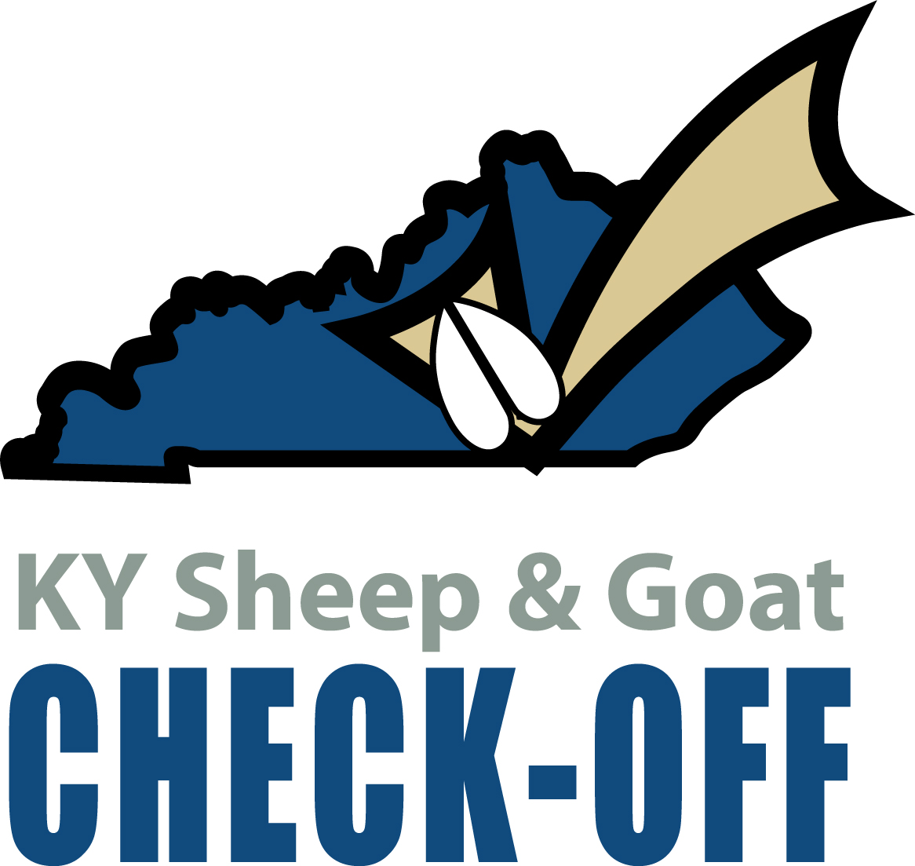

**Small Ruminant Boot Camp Application**

**Overview:** The Kentucky Sheep and Goat Council will use check-off dollars to cost share three Small Ruminant Boot Camps in 2025. Funds are available to provide small ruminant education in the areas of nutrition, health, quality assurance, hoof care, and parasite management. **Depending on location, this program may require additional funds from the applicant.**

**Eligibility:** Funds will be made available to Cooperative Extension Areas within the state of Kentucky.

**Timeline:** Applications open February 1, 2025 and will close when three camps have been scheduled. Programs must be completed by December 30, 2025.

**Grant Requirements:**

* **Grantee must agree to assist the KY Sheep and Goat Checkoff Board in marketing the event and providing food.**
* **Grantee must use the Kentucky Check-Off logo on all promotional materials such as flyers, websites, social media, etc.**

The Kentucky Sheep and Goat Check-Off Board wants to help you provide hands-on education to small ruminant producers. The Small Ruminant Boot Camps can be half or whole day programs, but may require producers to watch mandatory videos before attending the in person program in order to receive certain certifications.

The Checkoff Board wants to encourage Cooperative Extension Agents for Agriculture & Natural Resources to team up and offer a Small Ruminant Boot Camp in an area. As an agent, you are asked to:

* recruit participants, with a 20 household minimum; social media images and flyers will be provided
* secure food for the program; **a registration fee of $35 will be charged to participants to help recoup food and supply costs** *(Registration fees can be taken through the KSGDO website)*
* secure location for the program
* secure local animals for demonstrations
* provide assistance for setup and dissemination of the program
* door prizes can be provided but are not mandatory

In exchange for Extension Agent participation, the Checkoff Board will provide:

* recruitment materials
* instructors
* program supplies like microscopes, hoof trimmers, equipment, biosecurity supplies, etc.
* setup and take-down
* program evaluations and results

**Send completed applications to:**

**Kentucky Sheep and Goat Check-Off Program  
c/o KSGDO**

**1619 Bypass Road, PMB 159**

**Winchester, KY 40391**

**or**

**email to: kyates@kysheepandgoat.org**

**Questions - kyates@kysheepandgoat.org or (502) 682-7780**

**Kentucky Sheep and Goat Check-Off Program**

**Small Ruminant Boot Camp**

**Name of Group/Extension Area: _________________________________________________**

**Contact Person: ________________________________________________________________**

**Address: ______________________________________________________________**

**City: __________________________ State: ________________ Zip: ____________**

**County(ies): _______________________ Phone Number : (_____) __________________**

**Cell Number: (_____) ________________ E-mail: _____________________________**

**Date of Event: _________________________ Location: ________________________**

**Contact Person (if not same as above): __________________________________**

**How many projected participants:_____________________________________**

On the following page, please select if you would like to do a half or whole day program, as well as mark any add-on presentations you would like to offer:

**Half Day Program (4 hour minimum)- Choose the Option and/or Add-ons you prefer:  
 *Note: add-ons may extend the program to longer than 4 hours***

| * **Option 1** | * **Option 2** |
| --- | --- |
| * Hoof Trimming * Hoof health and care presentation * Hoof trimming demonstration * Hoof trimming practice | * Parasite Management * Parasite Control presentation * Parasite Prevention presentation * producers will receive:   + FAMACHA Certification   + Body Condition Score training |
| Add on options (circle preference):   * Nutrition/Health Connections presentation (45 minutes) * Hoof trimming demonstration (30 minutes) * Quality assurance basics (will not provide certification unless producers watch the SRQA videos in advance) (45 minutes) * Preparing for Kidding and Lambing presentation (45 minutes) * Understanding Forages (45 minutes) * Sheep and Goat Equipment & Use (45 minutes) | |

**Full Day Program (6 hour minimum, not including lunch)- Choose the Option and/or Add-ons you prefer:**

| * **Option 1** | * **Option 2** |
| --- | --- |
| * Parasitology Clinic (can do *one* add-on option)   + producers must watch three videos before attending   + producers will receive:     - FAMACHA Certification     - Body Condition Score training   + producers use microscopes to analyze their own livestock’s fecal samples   + presentation on why to conduct fecal samples (45 minutes) | * Hoof Trimming and SRQA Clinic (can do *two* add-on options)   + Hoof health and care presentation   + Hoof trimming demonstration   + Hoof trimming practice   + SRQA basics presentation   + Hands-on demonstrations for proper injection sites and administration, proper drenching, necessary equipment, biosecurity, and record keeping   + producers will receive SRQA Certification and record keeping system |
| Add-on options (circle preference):   * Nutrition & Health Connections (generally added onto the Parasitology Clinics) (45 minutes) * Fencing & Facilities (45 minutes) * Marketing (45 minutes) * Preparing for Kidding and Lambing presentation (45 minutes) * Understanding Forages (45 minutes) * Sheep and Goat Equipment & Use (45 minutes) | |

**Project Budget (*recommend contacting Kelley Yates to discuss before submission*):**

| **Income:** |  |
| --- | --- |
| **KY Sheep and Goat Check-Off Funds (registrations for 20)** | $700 |
| **Other: (specify)** |  |
| Local sponsors |  |
| Additional lunches (can also be taken through registration) |  |
|  |  |
|  |  |
|  |  |
| **Total Income:** | **$** |
| **Expenses:** |  |
| FAMACHA Cards ($25/person) |  |
| SRQA Certification ($5/person) |  |
|  |  |
|  |  |
|  |  |
|  |  |
|  |  |
| **Total Expenses:** | **$** |
| **Remaining Balance:** | **$** |